**Happy Baby to Goddess:**

**Creativity in Yoga Sequencing with Markov Chains**

**By Rachel Rosenberg**

https://github.com/rrosenb1/YogaSequenceGeneration

**Introduction**

I started practicing yoga five years ago. I was tight from frequent running, living in Ohio and in need of a creative and active outlet. While I was initially drawn to the immediate endorphins from yoga, I stuck around for the variety of movement and continued challenge that it offered. I completed teacher training last summer before moving to Chicago, and currently teach three classes per week around the city to people of all ages, places, and walks of life. Teaching is challenging in a completely new way; it forces me to think more about the big picture of the class, to create sequences that will make students feel both challenged and successful, and to foster a sense of curiosity and presence that some students may not get elsewhere.

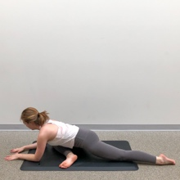As a teacher, it is easy to get in a rut of teaching the same poses, or the same sequences, repeatedly. The style of vinyasa yoga is intentionally free-form, eschewing the rigidity of more traditional kinds of yoga. Yet there exist unwritten “rules” in most vinyasa classes: that sun salutations must be used as a warm-up, or that *pigeon pose* signals the end of the “hard part” of class, or that open-hip poses need to come after closed-hip poses. Though these rules generally serve some purpose (if only just to keep classes familiar from one place to the next), I wanted to see if it could be possible to decrease the predictability of my classes and reinvigorate my students’, and my own, sense of curiosity about what would serve the body and what kinds of poses would best serve the goal of the practice. I also wanted to create a tool that could be useful to other teachers.

Pigeon Pose

There are a couple of key attributes to a “successful” yoga class, which I used to measure and improve the model while developing it:

**Variety:** The class must contain some variety in poses. Assuming a one-hour long class, students will not typically want to engage in too much repetition, especially if repetitive poses are challenging. A successful class will target similar muscle groups in several different ways, crafting a class that is challenging and targeted without being boring or monotonous.

**Challenge:** The class must be challenging to a wide variety of students. Students will come in with wide varieties of skill and experience levels; the class should accommodate both experienced and new students, incorporating modifications and options so that students can take as much or as little challenge as they need or want.

**Accessibility:** The class must be accessible to students with different bodies, abilities, and skill levels. A large amount of fulfilling this requirement falls on the teacher’s ability to offer options to the students in the moment: to put a knee down, or take a backbend with less depth, or to use a block under a hand to bring the ground closer. However, some of this also relies upon the model’s ability to contain poses that are modifiable; for this reason, I omitted poses from the corpus which would be prohibitively difficult for new students or those with injuries.

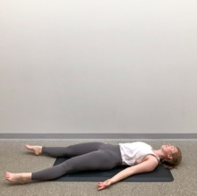**Rhythm:** The class must have a gradual rise-and-fall shape. This means that difficult poses need some warm-up, cooling poses need to fall after the peak, and *savasana,* corpse pose, should always be the final pose.

Savasana

I decided to use a discrete-time Markov chain to generate a full class. Markov chains contain a discrete set of concrete “states”. States are connected by “edges”, which represent the probability of transitioning from one state to another. In this case, the states are the poses themselves and the edges are the probabilities of transitioning from one pose to another. For example, at the top of the diagram **(1)**, there is a 33% chance of moving to *crescent pose* once in *downdog,* and a 25% chance that, once in *crescent*, the next pose would be *chair*.

In discrete-time Markov chains, the probability of moving to the next state depends only on the current state and not on previous states. While this project could also be done using a convolutional neural network such as an LSTM, a Markov chain achieves the same result, is much more simple to describe, and requires much less data. While the Markov chain for the full set of poses is very complex, the Markov chain for the top ten most frequent poses **(1)** is a good sample of the process.

**(1) |** Transition Model for Top Ten Poses

The idea here is that each pose can lead to a set of other poses; *downward facing dog* can move forward into *high plank*, can be used as a transition into standing poses, or can be the last pose before stepping to the top of the mat and standing at the end of a sequence. Each prediction is based only upon the current state of the system. Each of these outcomes gets associated with a probability, based on the data the model is fed. Then, based on the current state of the model, the next pose is chosen from the set of other poses the current pose has led to in the past, weighted by the probabilities that the current pose ends in each of its potential followers. In this way, the model is able to create a sequence that is both creative and familiar, unusual and comfortable.

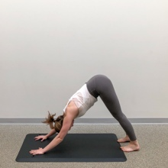 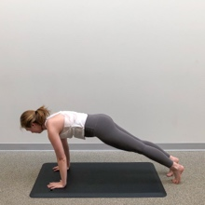

*Downward-Facing Dog to High Plank*

A note on vocabulary: I have stripped much Sanskrit text from the pose names in an effort for readability. In cases where Sanskrit names are primarily used in my classes or in others, I have included English translations.

**The Data**

The data set I used to train the Markov Chain **(2)** comprised of 1500+ combinations of about 130 common yoga poses, across 40 classes (about half of which were written by myself over the past year). Each class averages about 48 poses and lasts approximately sixty minutes. Each class is listed down the column.

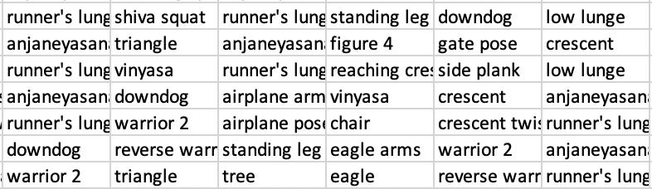

1. **|** Sample of Data

Though data that I created is easily accessible, one of my goals for the project was to foster creativity, so I wanted some variation to come in the form of classes written and taught by others. Several of the classes in the dataset are copies (or very close replicas) of classes taught by my teachers over the last few years; I have been in the habit of writing clever sequences after I take classes since I decided I wanted to teach myself.

The remainder are classes from Yoga Journal, a well-known site that provides advice, sequences, and short classes to other teachers and students. These introduced quite a bit of randomness into the dataset; they are often unorthodox sequences that, while using poses that are familiar to the average student, do not use easy transitions. This is a good thing for the generator because it introduces combinations of poses that are unintuitive to me; this gives the generator some unpredictability and creates low-probability options for common poses to lead to less common ones.

**Methods**

All analysis was completed in Python. Initial analysis primarily involved creating a transition matrix, visualizing results from the transition matrix, and creating a class for the Markov Chain that would retrieve rudimentary class sequences.

The first goal of the project was to create a transition matrix from the data. This required quite a bit of data cleaning (for example, “open to warrior 2” had to be changed to “warrior 2” for consistency) and standardization. I created a list of all of the states in the original data, representing all of the poses in the set. I then subtracted all of the poses that appeared only once or that were inaccessible to beginners (to help fulfill the “accessibility” goal for the project.) This left a set of 132 states used for the project.

Then, I calculated the transition matrix for the states in the data set. This is a 132 x 132 matrix, with a row and column for each pose, representing each transition in the data. When one pose, **m**, leads to another, **n**, the index [m, n] in the matrix M is incremented by one. Then, each value in the row is divided by the row total to yield a probability that the current state **m** results in the next state **n**. This creates a transition matrix **(3).**

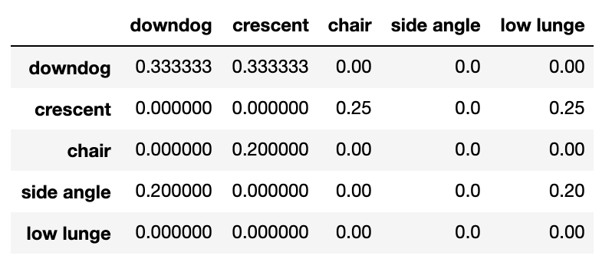

**(3) |** Sample of Transition Matrix

A heatmap of the fifteen most common poses **(4)** shows the wide variety of options for the most widely used poses. This shows that poses like *downward-facing dog* tend to go one of two ways – toward *crescent pose* or toward *anjaneyasana* – and poses like *child’s pose* are much more versatile, and have a high probability of resulting in one of many poses (*warrior two*, for example, can lead to any of ten of the most common poses – as well as several of the less common poses.)

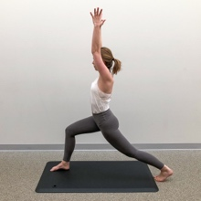🡨 🡪  🡨 🡪 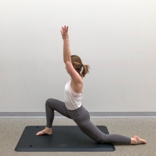

*Downward-Facing Dog (b) can go towards Crescent Pose (a) or toward Anjaneyasana (c).*

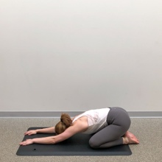 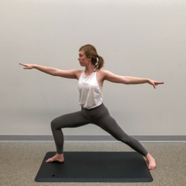

*Child’s Pose Warrior 2*

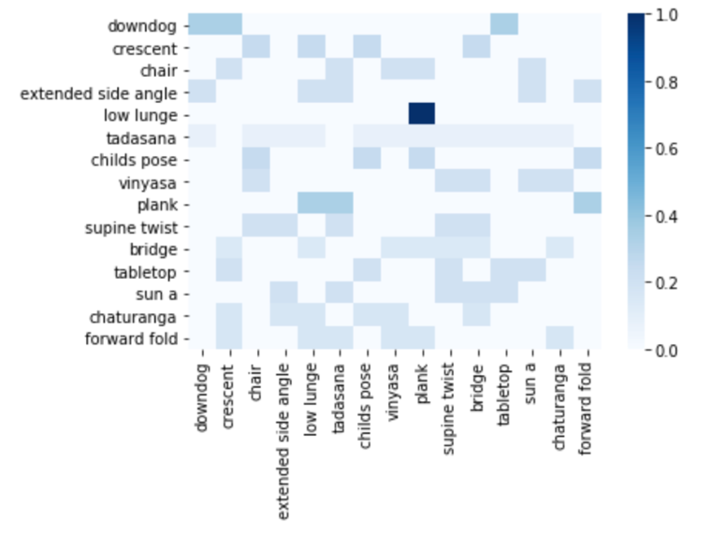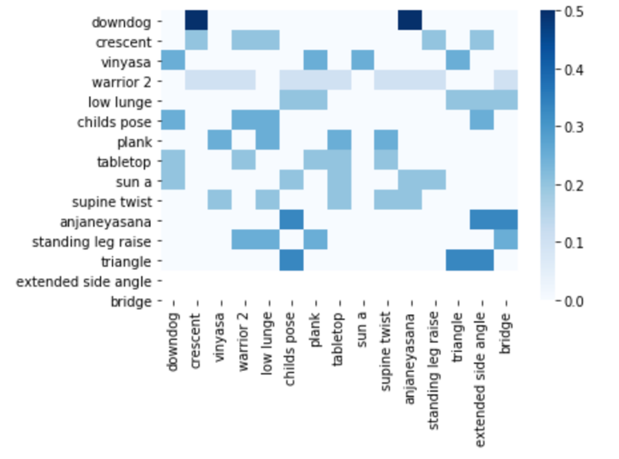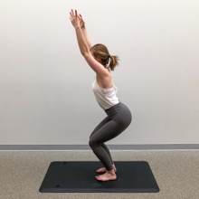Furthermore, an analysis of the fifteen most versatile poses **(5)** revealed huge variation in which poses may lead to others. While there is some overlap between most common poses and most versatile poses, there are a couple of illuminating differences. For example, it is interesting that *chair pose* appears in the most versatile poses but not in most common; it is frequently used as a strong transition for other poses, but is difficult for students to hold, so tends to be used less frequently in public classes (which must be accessible to beginners as well as more advanced students.)

**(5) |** Heatmap of Fifteen Most Versatile Poses

**(4) |** Heatmap of Fifteen Most Common Poses

On the opposite side of the spectrum, *standing leg raise* appears strongly in the most commonly used poses, but does not appear in most versatile poses. This is likely because, for public classes (particularly, possibly, in mine,) *standing leg raise* can be used primarily as a transition to *tree pose*, *eagle pose*, or *hand to foot pose*, though in more advanced classes *standing leg raise* would be a gateway to several arm balances and more advanced standing balances.

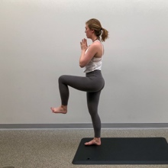 🡨🡪 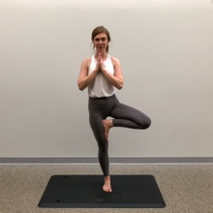 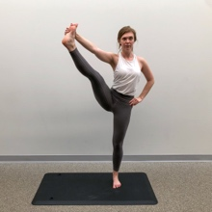 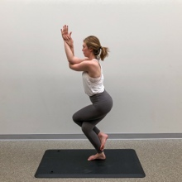

*Standing Leg Raise Leads to… Tree Pose Hand-to-Foot Eagle Pose*

After creating the transition matrix, I created a class for the Markov Chain object. The MarkovChain class has functions to generate a single next state and to generate a sequence of **n** states based on a user-defined or random initial state. The class relies heavily on numpy’s random.choice() function, which selects a value “randomly” from a list and allows each candidate value to be weighted, in this case by a probability defined by the transition matrix. This ensures that the generator will choose a next option, after each pose, proportional to the various options given to the current pose in the dataset.

The first several results **(6a)** were somewhat nonsensical; though they made sense based on the data, they may not have been possible to teach in an actual class. The first gets stuck in a repetitive loop of starting poses; this happened after I introduced a specific class of starting poses (more on this later), and resulted in a class that was possibly very simple but probably not very interesting.

The second of the sample initial results **(6b)** definitely made more sense, but still has several odd transitions. For example, *warrior 2* to *crow* happens twice during this sequence, though it happens zero times in the training data; this was because the matrix was being flattened over rows rather than columns. Once I fixed this, and removed accidental preferences for starting classes, sequences began to make remarkably more sense.

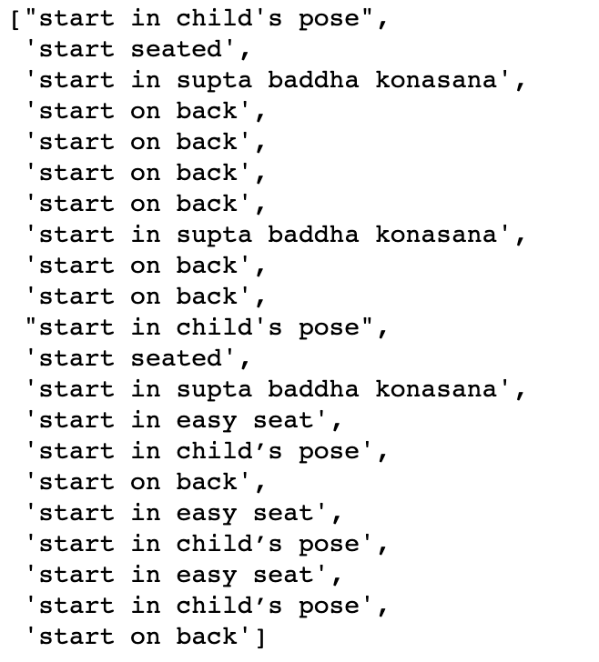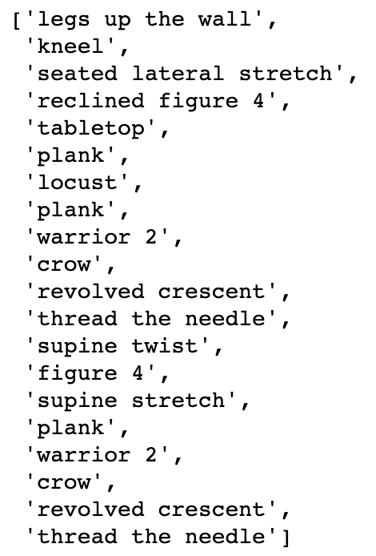

**(6a) and (6b) |** Initial Results

**Model Refining**

Once the initial class was built and working, I started to refine the model so that results would make more sense, possibly enough to be taught in a class setting. These fixes primarily involved classifying poses to appear in certain parts of each class and ensuring that a single pose could not appear many times in the same sequence.

The first step to take was separating the corpus of poses into five primary classes: Starting Poses, Centering Poses, Warming Poses, Standing Poses, and Cooling Poses. Examples, and quantities of each, are as follows:

|  |  |  |
| --- | --- | --- |
| **Class** | **Count** | **Example Poses** |
| Starting Poses | 5 | Child’s Pose  Easy Seat  Supta Baddha Konasana (Reclining Bound Angle Pose) |
| Centering Poses | 4 | Legs Up the Wall  Neck Rolls |
| Warming Poses | 38 | Boat Pose  Forearm Plank  Spinal Balance  Puppy Pose |
| Standing Poses | 108 | Warrior Poses (1, 2, and 3)  Dolphin Pose  Pyramid Pose |
| Cooling Poses | 22 | Seated Forward Fold  Pigeon Pose  Happy Baby Pose |

There was also some overlap between the poses. For this reason, they all had to be manually classified. For example, *supine twists* are frequently used both at the beginning and at the end of a class, particularly when the class involves standing twists. Core work (*boat pose*, *high plank)* may be used at the beginning of a class to warm students up or toward the end of a class to get a final burn before rest. In my recommendations, I will discuss how pose classification may be automated in the future.

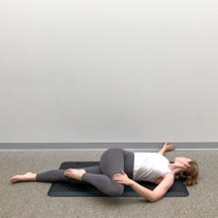 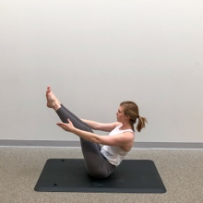 

*Supine Twist, Boat Pose, and High Plank*

One of my success metrics was that a class have a flowing rhythm. While creativity in a class is a great and desirable thing, it should not be so much as to be distracting and take a student from his or her body because of confusion or awkwardness. For this reason, I built a structure into the generator. Given **N** number of poses in a sequence, the generator will provide one starting pose and one centering pose (a breathing exercise or simple stretch) and will fill the remaining space with 25% warming poses, 50% standing poses, and 25% cooling poses. This yields results **(7)** which are much more reasonable, and which very possibly could be taught to a public class of all levels and meet the criteria of a) variety, b) challenge, c) accessibility, and d) rhythm.

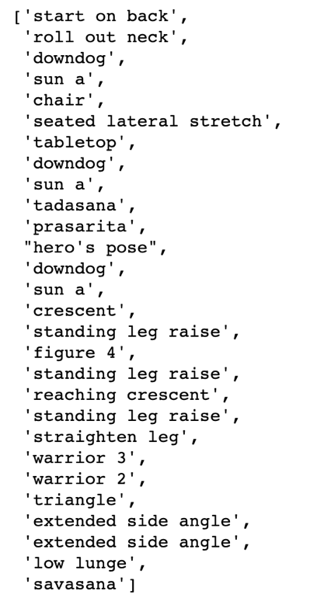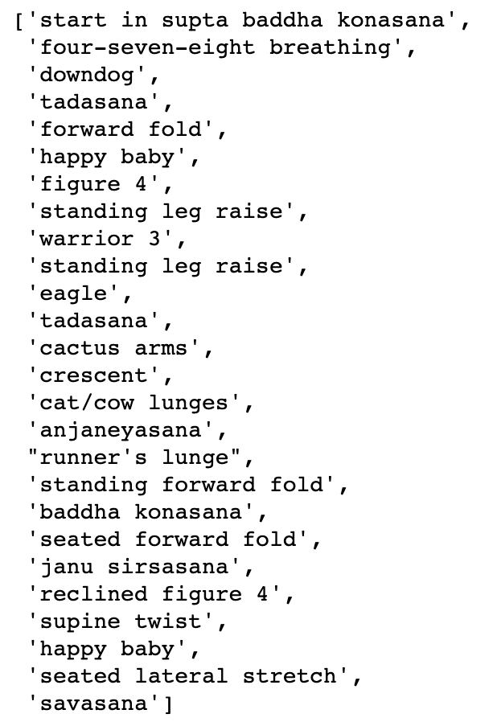

**(7) |** Some Final Results from Sequence Generator

**Visualizations**

The ideal use case for this application would be for myself and other teachers to gain inspiration for sequences to use. Teachers typically engage with this kind of content in clean, clear, grid-based sets of sequences like one would find on Pinterest **(8)**; they may also share sequences that are either exceptionally clever or visually stunning on their pages or with other teachers. It is easy to create a beautiful image; it is more difficult to deliver a particularly unique sequence.

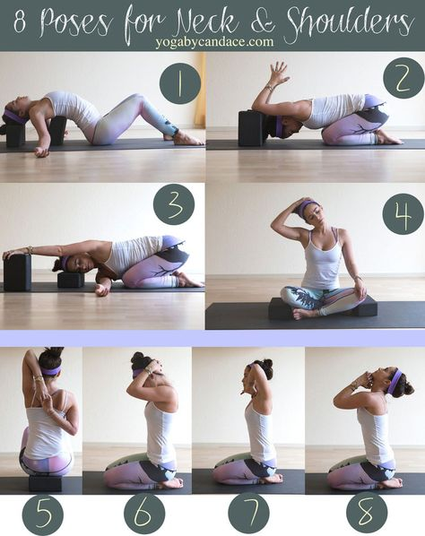

**(8) |** Sample Flow from yogibycandace.com

This type of image could be highly useful to students who practice from home and are tired of seeing the same videos or images over and over; for this audience it is also critical to display this information visually. From the standpoint of possible end users, it is important to have visually appealing designs and sequences.

The first of my grid-based visualizations **(9)**, created in Python using the Pillow package for images, was plain and lacked both strong design elements and consistency. I didn’t like that the photos (stock photos chosen from an internet search) didn’t match or that the text was simple. I wanted the final product to be clean, clear, and approachable; I wanted it to look like something that would actually be taught.

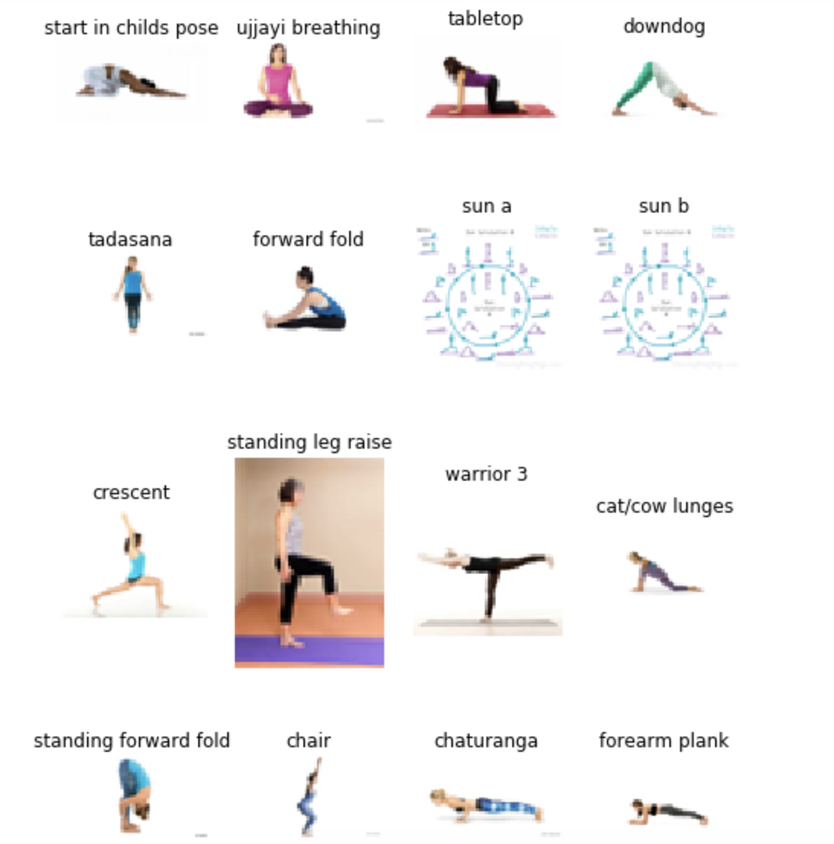

**(9) |** Subset of Initial Visualization

To remedy this, I took and added my own clean, standardized photos to the same grid-based style of visualization **(10)** using Canva and Adobe Lightbox. This version is more likely to be seen and shared because it is clear, consistent, and free from distractions. Since it is more eye-catching, it may be more engaging to the intended audience of teachers and self-taught students, while providing examples of correct alignment in each of the poses.

In the future, the model may be extended to automate design of the final visualization. I took and saved photos of nearly every pose in the corpus; these could be added to a template in a package like Pillow or Matplotlib and retrieved along with the generated sequence list. Future steps and recommendations will be discussed at length in the next section.



**(10) |** Final Visualization

**Recommendations**

In the future, I would want to improve the generator by making the model more complex, adding a wider variety of poses, and adding the option to choose goals or themes for generated classes.

One goal is to manually define much less of the sequence. This way, the generator would gradually be able to find a rhythmic rise and fall of a class without being specifically directed to do so. I could achieve this by using either a multi-step Markov Chain (an algorithm that would make predictions based on the last two or three steps back) or an LSTM. Since this project focuses on generation of a sequence, an LSTM or bi-directional LSTM would be a great candidate. Either of these models could be made to generate a class pose by pose rather than character by character (as would be the case in a traditional LSTM). A bi-directional LSTM could add visibility into previous poses to help determine the next; widening the number of previous steps considered could prevent repetition and aid in making sequences more novel and interesting.

I also want to allow for more complex sequences and for more difficult postures in the model. One famous teacher, Sri Dharma Mittra, recognized over 1,350 poses; this model contains fewer than 10% of his available options. A generator with more variety may tend to target more advanced students; however, those students may be more comfortable with creativity and uncertainty, and so this may be quite well-received.

Many successful classes work as well toward a specific goal, such as a peak pose or a certain body part to stretch out. I would like to implement this idea into the generator and have it, for example, generate a class that is heavy in backbends or that prepares the student for a more advanced arm balance. This also may come from feeding more data (likely labelled data would work best) and/or from using a more complex model.

**Conclusions**

Completing this project helped me to create material to teach, to visualize my own teaching via heatmaps, and to dive deep into the combination of two things, analytics and yoga, that I love very much. The final result has potentially huge use for teachers as we, collectively, search for new combinations of poses and novel ways to keep classes interesting and engaging. It may also allow for people practicing at home to follow along with a sequence that they have never tried, or seen, before. There are 5.9x1026 combinations of these 132 poses, assuming 25 poses per class, so the possibilities are practically endless.

While teaching this and simultaneously developing this model, I was reminded of how much goes into teaching yoga besides the poses themselves: the cues, the tone of voice, the gradual rise and fall of the class like the rise and fall of the breath. The modifications to most poses that must be offered to accommodate students of all body types and comfort levels. The improvisation that comes with teaching public classes.

In the past few weeks, I have had first-time students, a pregnant student on a day that I had planned twists (this is a big no-no), and a student with bad wrists on a day that I had planned a sequence on hands and knees. These situations require the ability to think on-the-fly and adapt the sequence to the students who show up for the class, not for the ideal student. Not every person can do every pose; not every sequence will work for every body. No human, nor any computer, can prepare for every eventuality. The real value in the generator is its ability to suggest unorthodox combinations of poses and to inspire creativity in its user.

**Sources**

https://www.datacamp.com/community/tutorials/markov-chains-python-tutorial

https://medium.com/@__amol__/markov-chains-with-python-1109663f3678

https://stackoverflow.com/questions/36006136/how-to-display-images-in-a-row-with-ipython-display/38556650